**Project:**Designing the visual composition and temporal behavior of a GUI is an important part of software application programming in the area of human–computer interaction. Its goal is to enhance the efficiency and ease of use for the underlying logical design of a stored program, a design discipline named usability. Methods of user-centered design are used to ensure that the visual language introduced in the design is well-tailored to the tasks.

**Main form:**

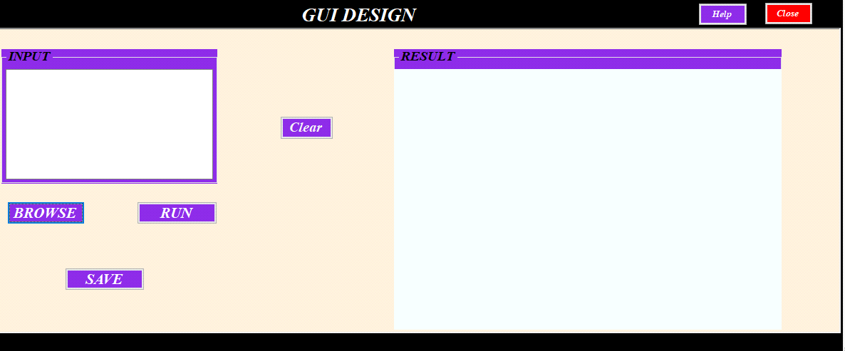

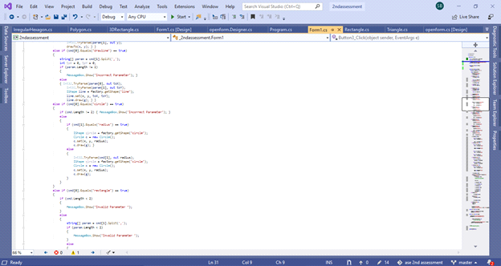

**Circle Class:**

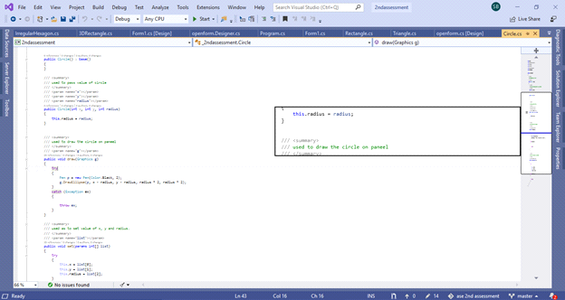

**Rectangle class:**

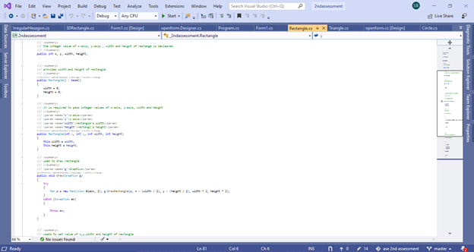

**Polygon class:**

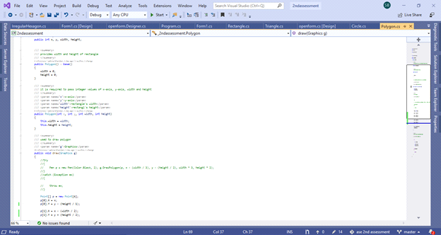

**3d rectangle:**

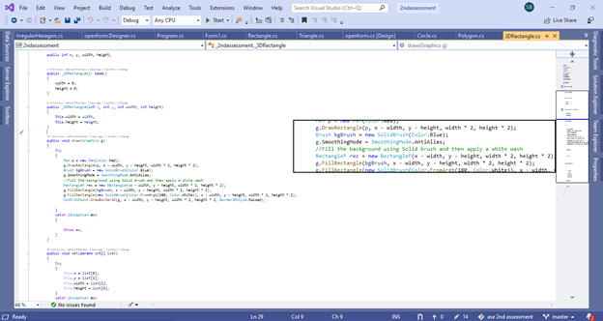

**Triangle:**

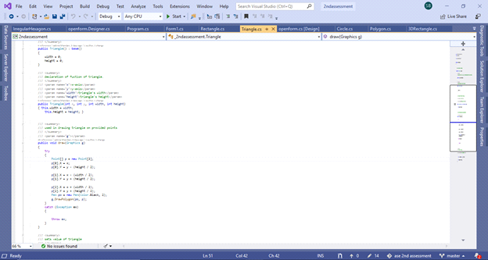

**Irregular hexagon:**

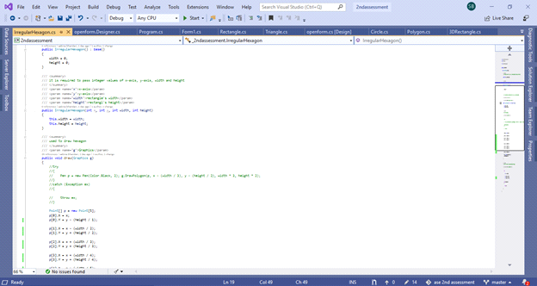

**Line:**

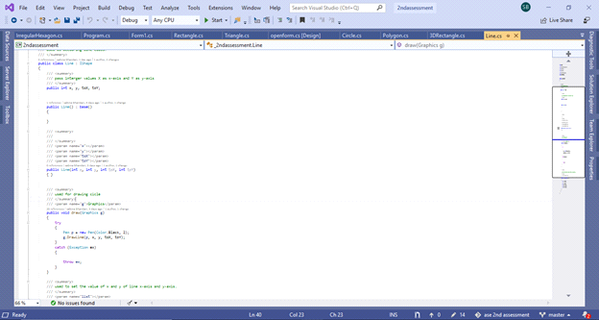

**Unit Testing:**

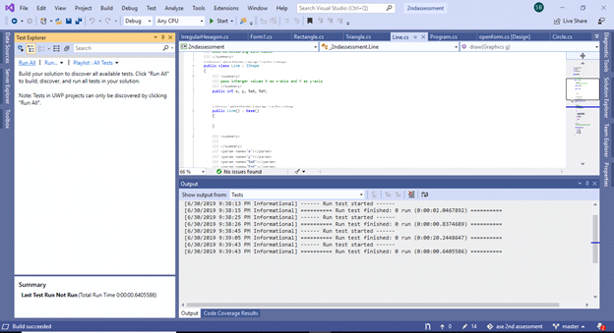

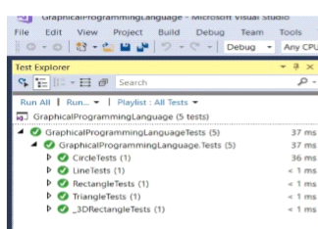

|  |  |  |  |
| --- | --- | --- | --- |
| **What was tested** | **Expected output** | **Actual Output** | **Remark** |
| **Circle Set Parameter tested** | **The value of x, y and radius of circle class should be same as the value passed in circle test class** | **As expected the value x, y and radius of circle class was same as the parameter provide in circle test class** | **Successful** |
| **Rectangle Set Parameter tested** | **The value of x, y, width, height rectangle class should be same as the value passed in rectangle test class** | **As expected the value x, y, width and height of rectangle was same as the parameter provided in rectangle test class** | **Successful** |
| **Triangle Set Parameter tested** | **The value of x, y, tox and toy triangle class should be same as the value in triangle test class** | **As expected the value x, y, tox and toy triangle was same as the parameter provided in triangle test class** | **Successful** |
| **3DRectangle Set Parameter tested** | **The value of x, y, width and height of 3drectangle class should be same as the value passed in 3drectangle test clas** | **As expected the value x, y, width and height of the 3drectangle was same as the value provided in 3dredctangle test class** | **Successful** |